
UT/ECQP/1223/B 09-NOV-2023
UNIT TEST (2023-24)
Subject: Economics  Grade: XII |  |  |  | Max. Marks: 50  Time: 2 ½ hrs
Name: |  |  |  | Section: |  |  | Roll No:
General Instructions:
- This question paper consists of 4 printed pages.
- All answers to be written in the answer sheet provided.
Macroeconomics- Section A Total Marks 22
 | “When MPC is greater than MPS, the value of multiplier is greater than 5.” True or False? Justify |  |  |  |  |  |  | 1
 | In case of underemployment equilibrium, which of the following alternative is not true? |  |  |  |  |  |  | 1
 | a. | Ex-ante Aggregate demand is equal to Aggregate supply | b |  | There exists excess production capacity in the economy
 | c. | The government should adopt surplus budget to correct this situation | d |  | The resources of the economy are not fully utilized
 | Which one of the following is a pair of direct tax |  |  |  |  |  |  | 1
 | a. | Excise duty & Wealth Tax | b. |  | Service Tax & Income Tax
 | c. | Excise duty & Service Tax | d. |  | Wealth Tax & IncomeTax
 | What is meant by escheats |  |  |  |  |  |  | 1
 | “Fiscal deficits have no positive impact on the economy, instead lead only to inflation and a greater debt burden” True or false? Justify |  |  |  |  |  |  | 1
 | From the following data about a government budget find  a) Revenue Deficit ; b) Fiscal Deficit and c) Primary Deficit. |  |  |  |  |  |  | 3
  S.No. | Items | Rs. (cr.)
   | Tax revenue | 57
   | Capital receipts | 42
   | Non-tax revenue | 12
   | Disinvestment and other receipts | 32
   | Revenue expenditure | 89
   | Capital expenditure | 110
   | Interest payments | 70
- u | Answer both parts a) and b)  - Using a numerical example, explain how an increase in investment impacts the national income?  - Find out MPC, if an additional investment of Rs. 100 crores generates an additional income of Rs. 500 crores . |  |  |  |  |  |  | 3,1
 | Answer both part a) and b)  - ‘Under the Sarva Shiksha Abhiyan (SSA), the Government provides free education for universalizing elementary education.” Identify and discuss which objective of the Government Budget is met by the scheme.  - Categorise the following into capital or revenue expenditure. Give reasons:  - Purchase of defense equipment from Germany:  - Payment of salaries to staff of government hospitals |  |  |  |  |  |  | 2,2
 | Explain the concept of underemployment equilibrium with the help of a diagram. Explain two measures under an easy monetary policy to reach full employment. |  |  |  |  |  |  | 6
 | Section B-Indian Economics Total Marks 28
- . | Assertion (A): Human capital formation is required for effective use of physical capital.  Reason (R): Formation of human capital raises life expectancy of the people. |  |  |  |  |  |  | 1
 | (a) Both Assertion (A) and Reason (R) are true and Reason (R) is the correct explanation of Assertion (A). |  | b |  |  | Both Assertion (A) and Reason (R) are true and Reason (R) is not the correct explanation of Assertion (A).
 | (c) Assertion (A) is true but Reason (R) is false. |  | d |  |  | Assertion (A) is false but Reason (R) is true.
 | Significance of human capital was recognised in______ Five-Year Plan. |  |  |  |  |  |  | 1
 | a) Third |  | b) |  |  | Second
 | c) Seventh |  | d) |  |  | Fourth
 | Define Agricultural Marketing |  |  |  |  |  |  | 1
 | (a) Both Assertion (A) and Reason (R) are true, and Reason (R) is not the correct explanation of Assertion (A) |  | b |  |  | Both Assertion (A) and Reason (R) are true, and Reason (R) is the correct explanation of Assertion (A)
 | (c) Assertion (A) is false, but Reason (R) is true |  | d |  |  | Assertion (A) is true, but Reason (R) is false.
 | Study the following picture and answer the given question:  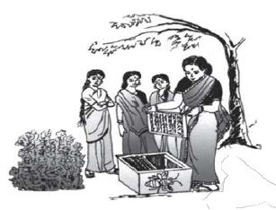  Women in rural households take up bee- keeping as an entrepreneurial activity. Such kind of  activities may be envisaged under _________ as diversification activity. (Choose correct alternative) |  |  |  |  |  |  | 1
 | (a) Animal husbandry |  | b |  |  | Fisheries
 | (c) Horticulture |  | d |  |  | Poultry
 | Carrying capacity implies :  (1) resource extraction should remain below the rate of resource regeneration.  (2) resource extraction should remain above the rate of resource regeneration  (3) generation of waste should remain within the absorption capacity of the environment  (4) generations of waste should be more than the absorption capacity of the environment |  |  |  |  |  |  | 1
 | (a) Statement (1) and (4) |  | b |  |  | Statement (1) and (3).
 | c) Statement (1) and (3) |  | d |  |  | Statement (2) and (4)
 | “Human capital formation give birth to innovation, invention and technological improvement” Do you agree with the given statement? Support your answer with valid arguments. |  |  |  |  |  |  | 3
 | “Ministry of Health & Family Welfare received an allocation of Rs 89,155 crore in the Union budget 2023-24, an increase by 12.6 per cent compared to the revised Budget estimates for 2022-23. Announcing a slew of measures for the Union Health Ministry, the nodal ministry tackling the worst health crisis in last many decades in the form of covid-19, Finance Minister Nirmala Sitharaman said the government aims to focus on skilling, research and innovation in the sector as the pandemic heightened the need. According to the Economic Survey 2022-23, Central and State Governments’ budgeted expenditure on the health sector reached 2.1 per cent of GDP in FY23 (BE) and 2.2 per cent in FY22 (RE), against 1.6 per cent in FY21. However, in the current budget, which is the last full budget of the Modi 2.0 government, the budgeted expenditure on the health sector stood at around 1.98 per cent of the GDP. This is when the National Health Policy, 2017 envisages raising public health expenditure to 2.5 per cent of the GDP in a time bound manner by 2025. Business Today Feb 1st 2023  Discuss the reasons behind government intervention in the in education and health sectors. |  |  |  |  |  |  | 3
 | Analyse the trends in the growth rates of GDP and employment from 1990-2012  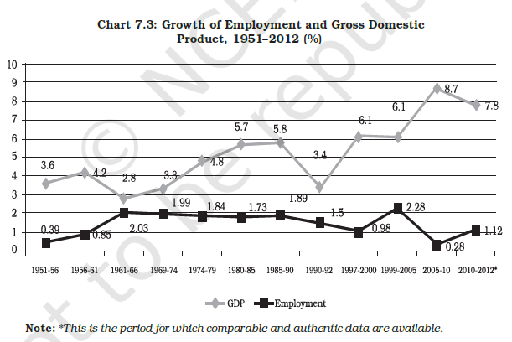 |  |  |  |  |  |  | 3
 | “India is on the cusp of surpassing China to become the world’s most populous country, and its economy is among the fastest-growing in the world. But the number of Indian women in the workforce, already among the 20 lowest in the world, has been shrinking for years. It is not only a problem for women but a growing challenge for India’s own economic ambitions if its estimated 670 million women are left behind as its population expands. The hope is that India’s fast-growing working-age population will propel its growth for years to come. Yet experts worry this could just as easily become a demographic liability if India fails to ensure its rising population, especially its women, are employed.” – Al Jazeera, 10th April 2023  What could be the reasons behind such a low workforce representation of women in general, and urban women, in particular? |  |  |  |  |  |  | 4
 | Attempt all parts:  - Define Sustainable Development  - In today’s scenario, pollution is one of the severe problems which India is facing. Elaborate how the application of the traditional practices can be helpful in achieving the objective of sustainable development. |  |  |  |  |  |  | 1,3
 | Answer all parts:  - Critically assess the success of rural credit and banking system in India  - How can Information technology be used for rural development? |  |  |  |  |  |  | 4,2

***

